Veritas Cluster Server (VCS)

Linux Evaluation on Egenera for CSFB EMS Messaging Group

Overview:
CSFB was looking for a method to failover the broker process across different physical systems.

We met with Roshan D’Mello who was our Application contact for the testing and Raymond Lee from R&D was the Systems contact.

Lowell Shulman and I set up VCS to do basic failover from one system to another.

The environment was 2 –Egenera nodes emctords18 and emctords19 running Red Hat 2.1 erata 25 both SAN connected to EMC DMX1000.

See attached:

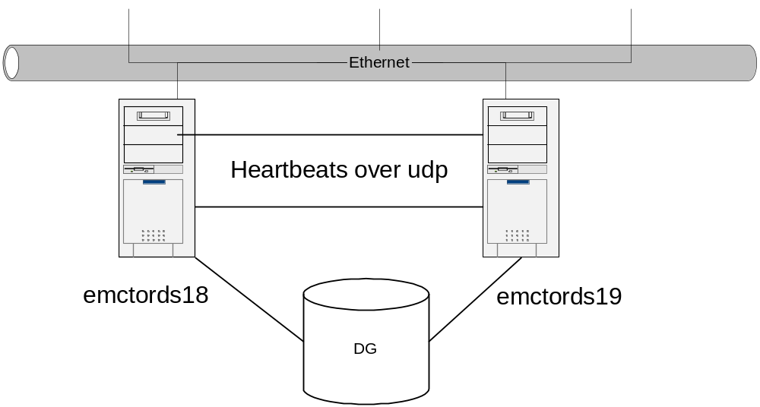

After some OS issues we installed VCS on Linux, we then configured our heartbeats over the Egenera backplane.

Here was the configuration we used

set-node emctords18
set-cluster 1
#configure Links
#link <tag-name> <device> <node-range> <link-type> <SAP> <MTU> <IP-address> <bcast-address>
link link1 udpdev - udp 0x2345 - 192.1.2.1 192.1.2.255
link link2 udpdev - udp 0x2346 - 192.1.3.1 192.1.3.255

set-node emctords
set-cluster 1

link link1 udpdev - udp 0x2345 - 192.1.2.1 192.1.2.255
link link2 udpdev - udp 0x2346 - 192.1.3.1 192.1.3.255

#set address of each link for each node
#format: set-addr <node-id> <link tag-name> <address>
set-addr 0 link1 192.1.2.4
set-addr 0 link2 192.1.3.4
set-addr 1 link1 192.1.2.5
set-addr 1 link2 192.1.3.5
set-addr 3 link1 192.1.2.2
set-addr 3 link2 192.1.3.2

set–arp 0

#disable LLT broadcasts
set-bcasthb 0

We create resources for the Disk and the File System mount point to fail over
See example:
DiskGroup e4jms_san_dg (
DiskGroup = e4jms_dg
StartVolumes = 1
StopVolumes = 1
)

Mount e4jms_mount (
MountPoint = "/e4jms"
BlockDevice = "/dev/vx/dsk/e4jms_dg/ems_vol"
FSType = vxfs
FsckOpt = "-n"

Once this was configured we started our initial testing by rebooting the Egenera boxes

Init -6

Our tests showed the results:

Linux VCS

# Messages VCS failover time Bring up EMS Broker start time 0 7sec
100k 12sec 7sec 19sec
200k 11sec 20sec 31sec
300K 11sec 29sec 40sec
We also did testing based on a kill -9 on the “tibjmsd” process that was running to test for software failure
Here are the results:

# Messages VCS failover time Bring up EMS Broker start time
300K 11 28 39sec total

We also then created a application monitoring agent to monitor/ start and stop the application

See attached:
Application brokers (
User = rdmello
StartProgram = "/app/ems/brokers/dev1/eq/bin/start.sh"
StopProgram = "/app/ems/brokers/dev1/eq/bin/stop.sh"
MonitorProcesses = {
"/app/ems/4.0.0/bin/tibjmsd -config /app/ems/brokers/dev1/eq/config/tibemsd.conf" }

VERITAS would recommend also creating a Virtual IP address that can be used by either node.

The Service group would contain (the Virtual IP, Application, Mount and Disk Group) and would fail over as a unit with dependencies and be brought up in the proper order.

As for the tuning of the application:

As a best Practice the VCS consulting team would work with the E4JMS team to configure the software and VCS and tune it to failover in the most efficient manner.

See example:

